Cornwall Council- Skills training and Energy Saving Initiatives
A. Richards¹, Alice Clarke ² , Michael Hunt²
¹ Strategic Historic Environment Service, Cornwall Council. Andrew.richards@cornwall.gov.uk
² Cornwall College, Science and Natural Environment. michael.hunt@cornwall.ac.uk
Abstract – Traditional buildings are complex and work in different ways to new buildings. They are often hard to heat but need to be upgraded with ‘breathable’ as opposed to ‘air tight’ solutions. Well intentioned alterations to improve energy efficiency often harm original historic fabric and create unhealthy living environments for occupants. Perceived difficulties in upgrading older buildings lead many developers to prefer demolition and new build to conversion.
Cornwall Council has been using externally sourced funding to authentically repair traditional buildings in its historic towns and show how they can be sustainably repaired and upgraded without damaging their character and with health benefits to occupants.
This paper will briefly describe how this has been achieved through:
- Traditional skills training and energy monitoring programmes
- Production of web based energy saving guidance
- Life cycle cost comparisons of converting local historic buildings as opposed to demolishing and building new.
Keywords – Retrofitting;Skills training;Co-ordinated local approach

Introduction
Over the last 16 years Cornwall Council has successfully sourced national heritage led regeneration funding and implemented traditional repair schemes in its historic towns. These were mainly though Heritage Lottery funded Townscape Heritage Initiatives (THI’s), four year multi funded grant schemes with partnership funds over £1 million pounds. Grants of up to 75% were offered to around 30 buildings on each scheme for quality traditional repairs using local materials, reinstating missing architectural detailing and bringing vacant buildings back in to use.
12 heritage led regeneration schemes have been successfully implemented in Cornwall between 1998 and 2013. In addition Camborne, Roskear and Tuckingmill THI finishes in June 2016 and a new scheme in the historic market town of St Austell will start in 2017. Completed schemes have created £25 million pounds of investment (including £8.2 million private investment) in the historic towns through a combined Cornwall Council contribution of £1.7 million. The later schemes have progressed pioneering traditional skills and monitored energy saving measures which have benefited the local construction skills base and influenced local retrofitting proposals.

Traditional Skills Training and Energy Monitoring
Traditional buildings in Cornwall were robustly built with locally sourced stone and slate to withstand extreme local weather conditions. This produced a distinctive local character which is now under threat. There is a long standing shortage of specifiers and installers who understand traditional buildings and traditional building skills are rarely taught in colleges. Local contractors often prefer to replace rather than repair original building fabric and to demolish and build new rather than convert.
Traditional buildings with solid wall construction make up 25% of the UK building stock. Upgrading them to reduce energy consumption and carbon emissions is a generally accepted principle.. Retrofitting schemes, however, often use external non permeable ‘air tight’ insulation that prevents solid walls from ‘breathing’. This can cause water ingress, condensation and mould growth as well as obscuring original materials and details. Creating sealed environments is potentially damaging to occupants health and there is a need to balance insulation and ventilation. Tenant interviews on THI funded schemes revealed windows were rarely opened, a concern as Cornwall is a radon affected area.
To address these issues a THI in the Cornish settlements of Camborne, Roskear and Tuckingmill has funded and promoted high quality traditional repairs, organised training days for local contractors and architects and given local college students work experience on THI funded schemes (Fig.1).
Sympathetic ways of upgrading traditional construction have been installed on THI funded buildings. Performance of products and methods used have been monitored by local Renewable Energy and Carbon Management students as part of their coursework. So far monitoring has taken place on upgraded original timber single glazed windows (Fig.2) and natural breathable internal insultion (Fig.3). Results have been added to an ‘Improving Energy Efficiency in Cornish Historic Buildings’ guide [1]. This web based guidance produced by Cornwall Council illustrates local examples of good practice, provides updated costs and lifespans of products and includes web links to enable further research. The guide has been formerly endorsed by Cornwall Council and links to wider local policy and guidance. It is used early in the planning process and before Building Regulation applications to influence the quality of local retrofit schemes. The guidance concluded that retrofitting historic buildings required a ‘whole building’ approach taking on board location, construction, condition, effectiveness of building services, heritage value, significance and occupant behaviour.
The aim of these initiatives is to show that repairing rather than replacing original fabric retains original character and can be cheaper. Good and regular repairs help the performance of traditionally built buildings which can then be upgraded in ways that do not damage their character.. THI funded schemes provide opportunities to see how this has been achieved while the web based guidance provides feedback on performance, cost and lifespan of products used.
So far outputs from these initiatives include 24 training events for 534 local builders, professional agents and college students, ‘live’ training opportunities for over 100 local college students, good practice monitored energy saving methods to 40 building units and inclusion of traditional skills and energy monitoring as part of local college construction and renewable energy courses.
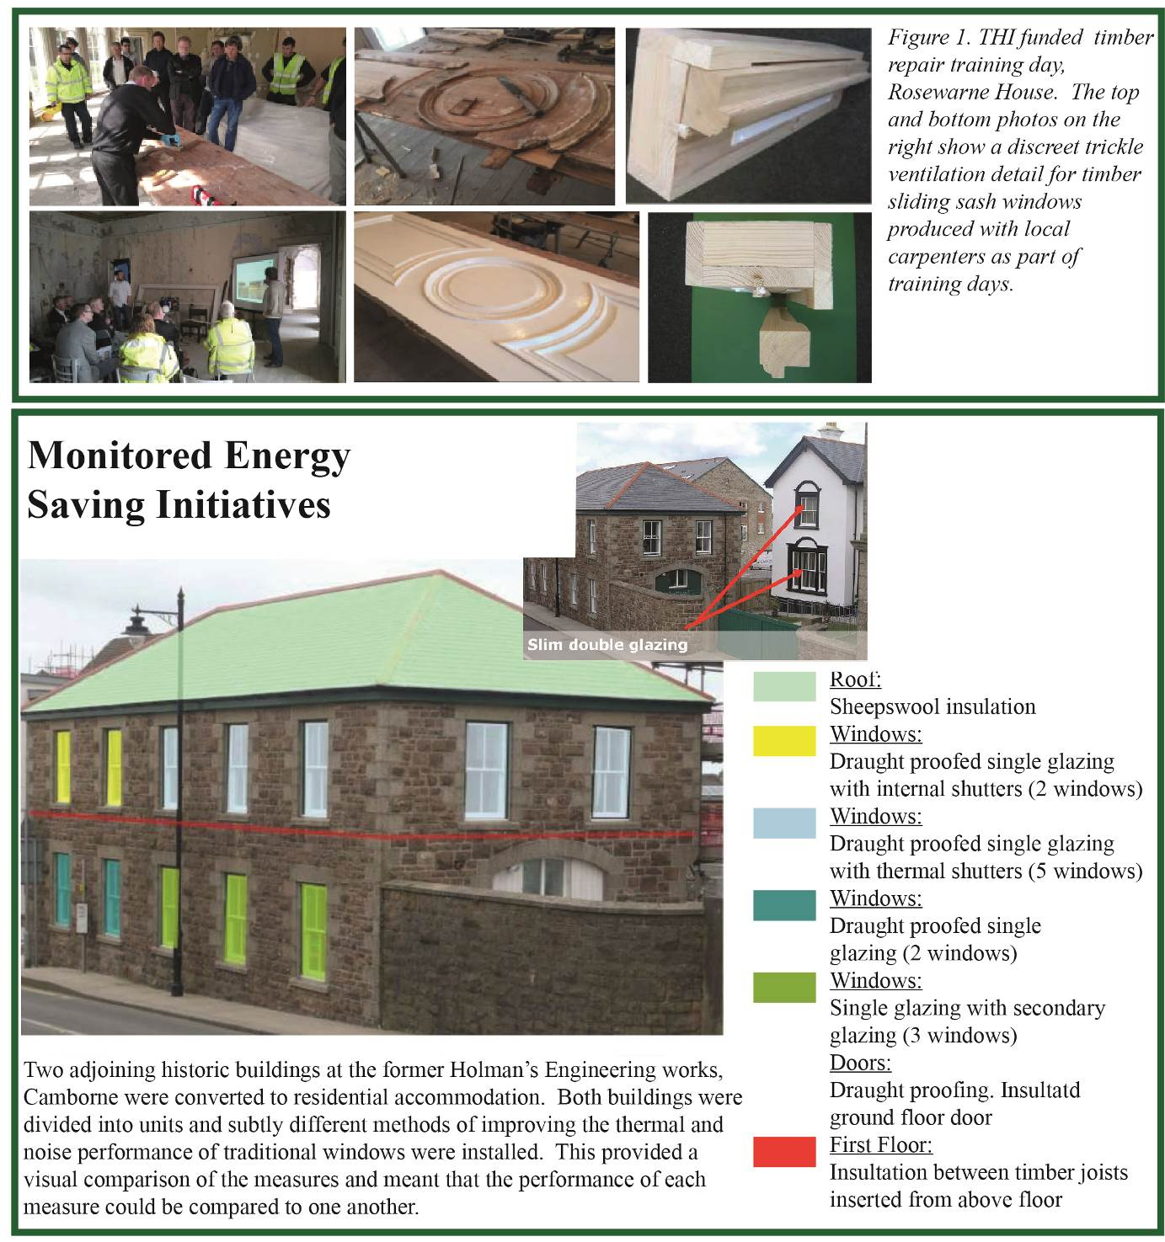

Figure 2. Example from ‘Improving Energy Efficiency in Cornish Historic Buildings’ guide. showing how timber single glazed sash windows can be upgraded by installing draughtproofing, secondary glazing, internal timber shutters and slim double glazing. Monitoring showed that all of these methods effectively reduced heat loss, reducing energy bills by 15% and £100 a year for occupants as well as providing good noise protection. The building was not listed and without grant aid unsympathetic upvc windows. could have been installed which would have damaged character.

3.0 -MONITORING OF ROSEWARNE HOUSE STABLE BLOCK CONVERSION
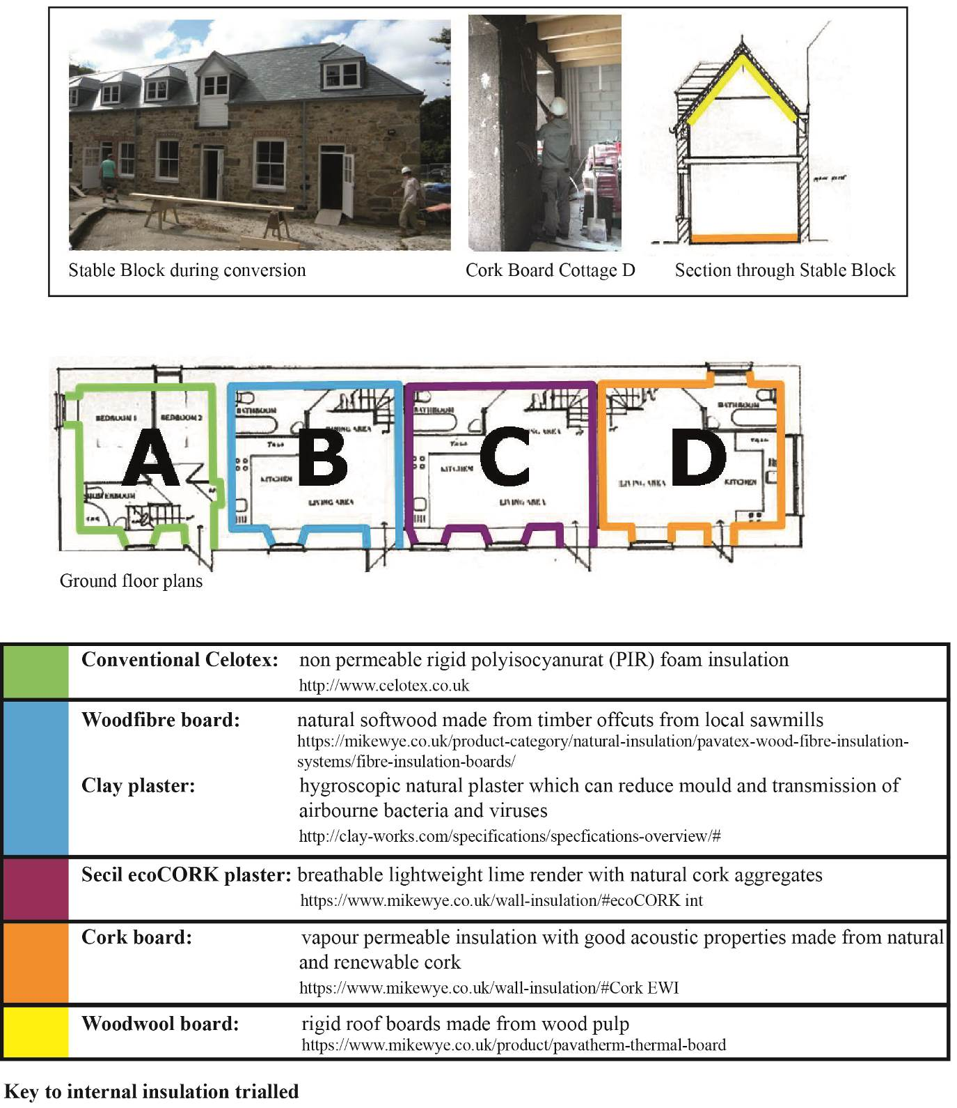
Figure 3. Monitored internal insulation, Stable Block, Rosewarne House

3.1 Introduction
A stable block with solid local stone walls at the rear of a grade 2* listed building is being converted to four separate cottages. Cottage A is being upgraded conventionally with internal non permeable Celotex PUR closed cell dry lining. The other three cottages are being internally insulated with different types of natural breathable insulation. Cottage B is being insulated with woodfibre board and clay plaster, Cottage C with ecoCork plaster and Cottage D with Cork board. 60mm insulation was fixed to internal walls and 20mm to window reveals to counter cold bridging. Monitoring will analyse:

- Whether breathable internal insulation affects the thermal performance of solid walls and whether damp problems are reduced and good air quality is maintained.

- The relative life cycle impact of retrofitting historic buildings compared to demolishing and building new. A retrofitted building’s thermal performance will usually be worse than that of a new building leading to higher in use energy and emissions. The analysis looks to what extent this is mitigated by the lower embodied energy and carbon of the retrofit and how this is affected by choice of materials.
Heat Flow measurements to date compare Cottage A with Cottage D (with normalised floor areas) and provide estimates of the embodied in use and overall energy and carbon of the conversion compared to a new building with masonry/ cement construction.
3.2 Monitoring
The 600 mm thick stable block walls have granite facing stones with a central core of stone, earth and air voids. This makes an accurate thermal resistance estimate difficult. Presuming the stone is granite and the earth/stone core ratio range is 20/80 to 80/20 then a steady state U-value calculation would estimate the R value of the stone wall to be 0.37 to 0.65 W⁻¹ K m², giving a U-value of 1.5 to 2.7 W K⁻¹ m⁻². Steady state calculations for finished walls after adding insulation give U values of 0.31 – 0.34 for Cottage A, and 0.74 to 0.94 for Cottage D.
The heat flux measurements were carried out over several days in the same manner as the authors mentioned, using thermistors pressed to the interior and exterior surfaces to measure temperatures T_{in} and T_{out}, together with a Hukseflux HP5 heat plate on the interior wall surface to measure the heat flux Q. The data were analysed in the manner of Biddulph and co-workers (Biddulph et al., 2014), by modelling walls as two thermal resistances R₁ and R₂, linked to an internal wall heat capacity C, with the initial temperature of the wall interior parametrised as T_{m,init}. A maximum likelihood estimation, using the mle() function in R was used to find the best fit values of these parameters. Temperature measurement plots and real and modelled heat flow measurements are shown in Figure 4.
Results show Cottage D walls have a thermal resistance of 2.65 W⁻¹ K m², and a U-value of 0.39 W K⁻¹ m⁻², while those of Cottage A are 2.96 W⁻¹ K m² and 0.34 W K⁻¹ m⁻². A bare wall U value measurement of Cottage A before insulation was 1.3 W K⁻¹ m⁻². This reduced U value difference impacts on the relative life-cycle impacts of the two type of construction. An estimate of embodied and in use carbon and energy use (including demolition and disposal) was made comparing the cottage conversion to a similar sized new building. This used a process LCA (Hammond and Jones, 2011) and a simplified building physics model based on SAP (BRE, 2012).. It was assumed from Moncaster and Symons, 2013),that this life cycle part accounts for 21% of embodied carbon and 5% of embodied energy. Results are summarised in Table 1 below:
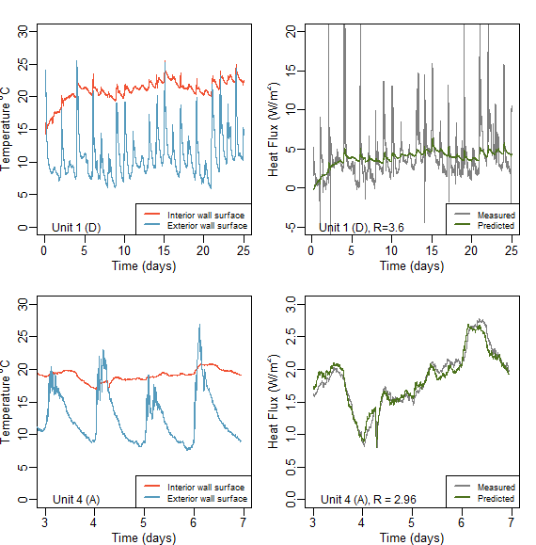
Figure 4: Left panels show interior and exterior wall surface temperatures of the two retrofitted cottages. Right panels show modelled (green) and measured (grey) heat fluxes through the walls of these units
Table 1: Summary of the embodied, in-use and lifetime (50 year) energy and carbon of the two retrofitted units and a conventional new-build of the same size.
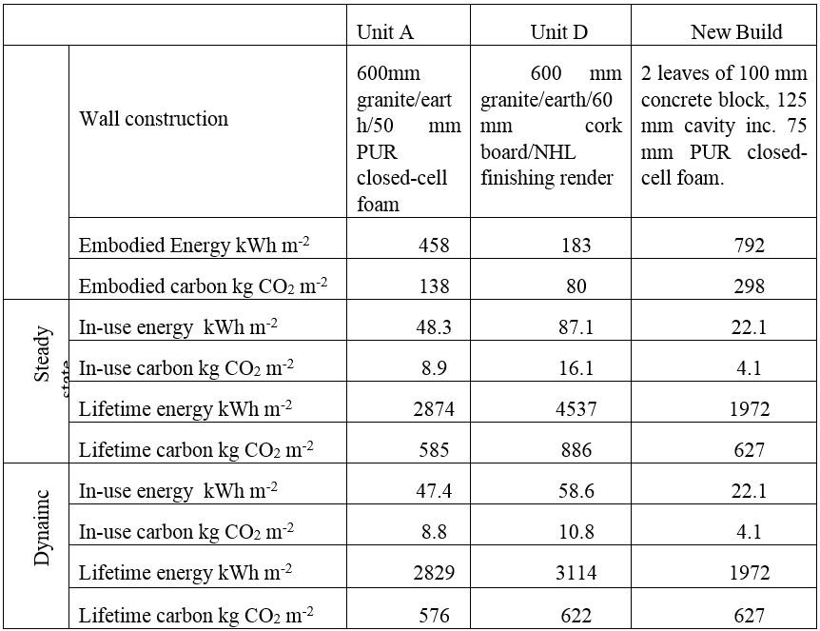

3.3 Conclusion

- The dynamic nature of heat flow through the thick solid walls shows that lifetime carbon emissions of the retrofitted cottages are comparable to those of the new build, even for cottage where less thermally insulating cork layer was used. Using this dynamic treatment significantly reduces lifetime emissions assumptions.
- There is scope for the natural product retrofit in particular to achieve lower emissions than either the modern material or new build options, given the likely reduction over coming decades in the carbon intensity of electricity, if space and water heating were switched to an electrical form.
- Cork boards and plasters used in Cottage D, as well as all roofing slates were imported from Portugal and Spain. Carbon intensities supplied by DEFRA show that the additional transport emissions due to this distance of travel are less than 1% of the lifetime building emissions, and thus not a major consideration.
- Full detailed results and analysis from the ongoing thermal and air quality monitoring carried out in the stable block will be available for the conference in October.

4.0 References
[1] A traditional skills training programme summary and ‘Improving Energy efficiency in Cornish Historic Buildings’ guide and can be accessed from the Camborne, Roskear, Tuckingmill Regeneration, Energy and Skills THI website:http://www.cornwall.gov.uk/environment-and-planning/conservation/heritage-led-regeneration/camborne-roskear-tuckingmill-townscape-heritage-initiatives/
[2] HeritageLotteryFundTownscapeHeritage:https://www.hlf.org.uk/looking-funding/our-grant-programmes/townscape-heritage
[3] Hukseflux heat flux, thermocouple sensors and NRG data loggers: http://www.hukseflux.com/page/products-services
[4] EVM-7 Air Quality Monitors: http://www.shawcity.co.uk/air-and-dust-quality/gravimetric-sampling/evm-7-all-in-one-environmental-monitor-temperature-rh-pid-co2-co-particulates
[5] Baker, P. (2011) ‘Historic Scotland Technical Paper 10: U values and traditional buildings’. Historic Scotland. Available at: http://www.historic-scotland.gov.uk/technicalpaper10.pdf.
[6] Biddulph, P., Gori, V., Elwell, C. A., Scott, C., Rye, C., Lowe, R. and Oreszczyn, T. (2014) ‘Inferring the thermal resistance and effective thermal mass of a wall using frequent temperature and heat flux measurements’, Energy and Buildings, 78, pp. 10–16. doi: http://dx.doi.org/10.1016/j.enbuild.2014.04.004.
[7] BRE (2012) Standard Assessment Procedure (SAP 2012). Available at: http://www.bre.co.uk/sap2012/page.jsp?id=2759 (Accessed: 27 May 2016).
[8] Department for Environment, F. and R. A. (Defra) C. D. webmaster@defra. gsi. gov. u. (2015) DEFRA Carbon Factors. Available at: http://www.ukconversionfactorscarbonsmart.co.uk/ (Accessed: 12 December 2015).
[9] Hammond, G. and Jones, C. (2011) ‘Embodied Carbon: The Inventory of Carbon and Energy’. BSRIA.
[10] Moncaster, A. M. and Symons, K. E. (2013) ‘A method and tool for “cradle to grave” embodied carbon and energy impacts of UK buildings in compliance with the new TC350 standards’, Energy and Buildings, 66, pp. 514–523. doi: 10.1016/j.enbuild.2013.07.046.

